Analysis of Selected Brief

Reasons for Selecting Brief

When I received my Project Brief I looked closely at all three options and was very satisfied with all three. However after sometime I realised my skills were being tuned to brief 1 & brief 3…..

After careful consideration………… I decided that brief 3 was more in line with where I could influence more marks from the brief and would also like the chance of being heavily involve in creating a ……. And being able to use this at home once it was finally made……

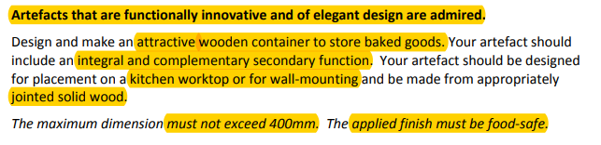

Keywords

Functionally -
Innovative -
Elegant -
Admired -

Attractive -
Container -
Baked Goods -
Integral -
Complimentary -
Secondary Function -
Wall Mounting -
Jointed Solid Wood -
Exceed –
Applied Finish –
Food Safe –

