Contents
- Analysis of Selected Brief (10 Marks)
Selection of Brief
Highlight Keywords
- Investigation/Research (10 Marks)

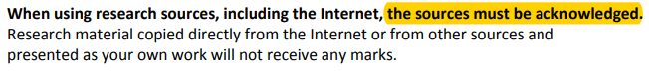
Page 1
Page 2
Page 3
Page 4
- Development/Sketches of Design Ideas (20 Marks)
Page 1
All Sketches MUST be fully Coloured and Annotated Clearly Talk about possible materials, joints, wall mounted, freestanding, fixtures & fittings…. screws glues & a finish….

Page 2
Page 3
Page 4
- Final Design Idea
- Working Drawing (20 Marks)
- Cutting List
- Manufacture of Chosen Solution
Fitness for Purpose (20 Marks)
Appropriate use of Materials (10 Marks)
Creativity (20 Marks)
Demonstration of Skills (sketches) (40 Marks)
Quality of Finish (20 Marks)
Overall Appearance (20 Marks)
- Evaluation (10 Marks)
- Acknowledgement of Thanks

(Delete all grey writing/symbols before you print)

