Investigation/Research
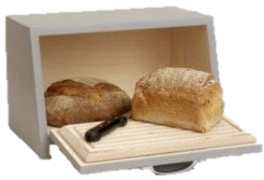

Really interesting design here… quite simple in its overall appearance yet challenging enough to mark out and fit together with quality joints
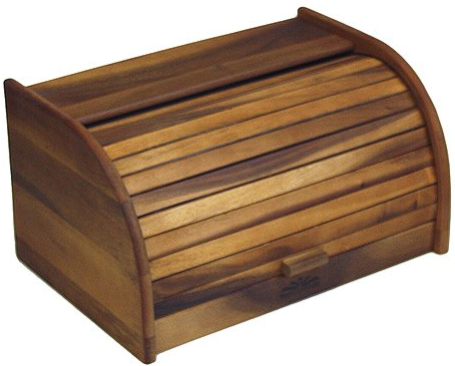
https://www.google.ie/search?q=baked+goods+storage&source

Really nice and appealing design however cover or lid has a really complicated arrangement that would prove too difficult. This would be something to try to avoid in the grand scheme of things.

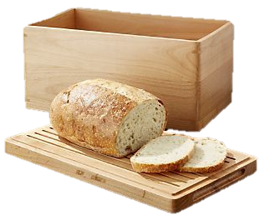
https://www.google.ie/search?q=baked+goods

Wonderful idea to create a lid that has a dual function or secondary function as a chopping board. This would certainly something to keep in mind for my overall design https://www.google.ie/search?q=baked+goods+storage&source

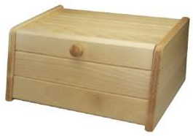
What appears to be a simple design but has potential to be more dramatic in its overall design.

http://buildbyself.blogspot.com/2015/02/

